MD2201: Data Science

Name of the student: Bhagwat Vinod Kolekar Roll No. 58

Div: ET-B Batch: B3

Date of performance:

Experiment No.4

Title: Regression .
Aim: i. To construct a simple linear regression model
ii. To construct a multiple linear regression model.

Software used: Programming language R.

Data Set: Toy Sales Dataset

Code Statement:
- Simple Linear Regression
- Consider the Toy sales data set.
- Apply simple linear model considering response as Unit sales and explanatory variable as Price.
- Plot the scatter plot and draw the regression.
- What are values of R-square and residual standard error? (Write in conclusion)
- Display all predicted values from the designed model and the corresponding values of error.
- Multiple Linear regression:
- Consider Toy sales data set.
- Consider all variables to fit the regression model.
- Compare the R-square of SLR with MLR. (Write in conclusion)
- Which of the variable is more significant? Why? (Write in conclusion)
- Can you reject Null hypothesis for promotion expenditure variable? (Write in conclusion)
- Which scenario from the following you will select to be applied to get maximum number of Unit sales? (Write in conclusion)
- Price=9.1$, Adexp=52,000$, Promexp=61,000$
- Price=8.1$, Adexp=50,000$,Promexp=60,000$

Code: (Write code for above statements here)

f <- read.csv("Toy_sales_csv.csv")

# Simple Linear Regression----
# lm = linear model. Syntax lm(y~x, data)
l1 <- lm(f$Unitsales~f$Price,f)
s1 <- summary(l1)

print(s1)

library(ggplot2)
p <- ggplot(f,aes(Price,Unitsales)) + geom_point() + geom_smooth(method = "lm", formula=y~x,col="red",se=F)

print(p)

pred <- predict(l1)
print(pred)

e <- f$Unitsales - pred
print(e)

# Mulitple Linear Regression----
l2 <- lm(f$Unitsales~f$Price + f$Adexp + f$Promexp,f)
s2 <- summary(l2)
print(s2)
df <- data.frame(Price = c(9.1,8.1),Adexp = c(52,50), Promexp = c(61,60))
df$Price<-as.numeric(df$Price)
df$Adexp<-as.numeric(df$Adexp)
df$Promexp<-as.numeric(df$Promexp)

pred2 <- predict(l2,df)
print(pred2)
df1 <- cbind(df,pred2)
print(df1)

Results: Display the output obtained on R console for all the cases.

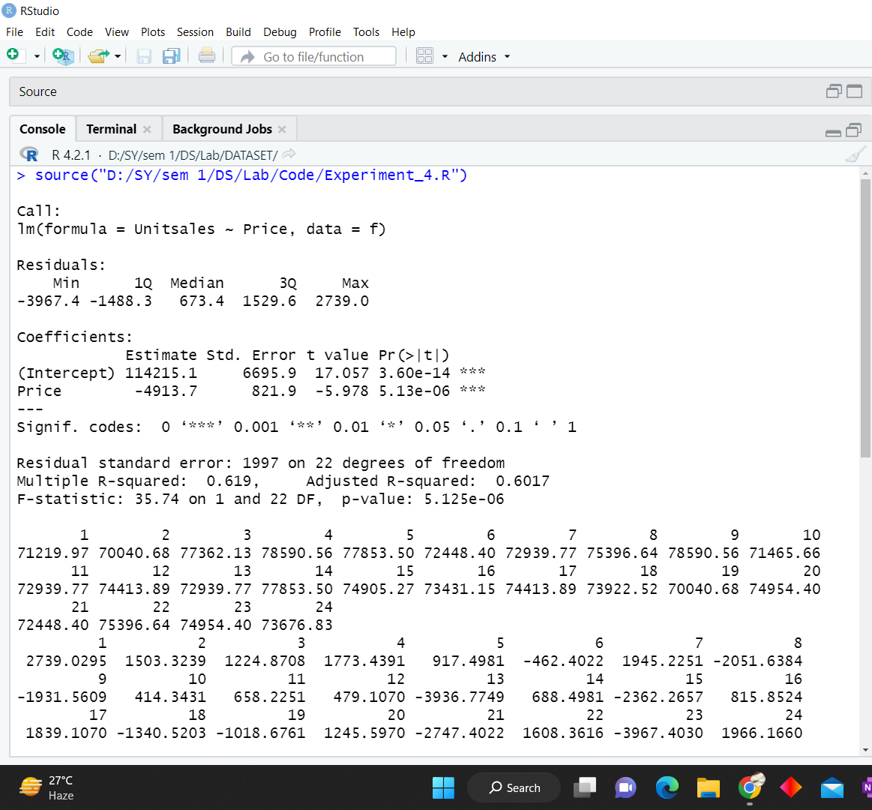

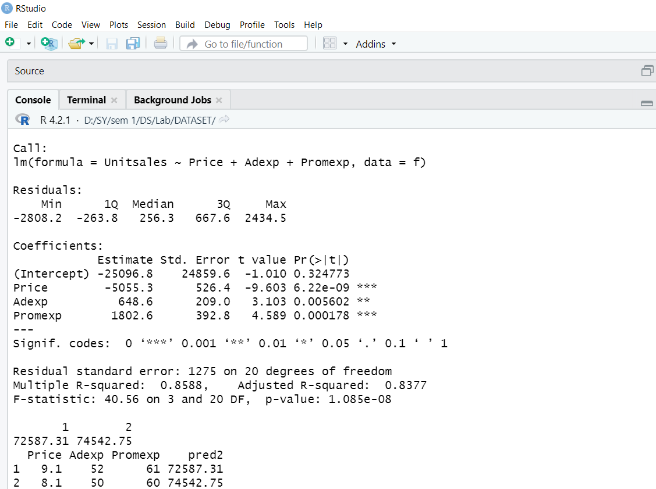

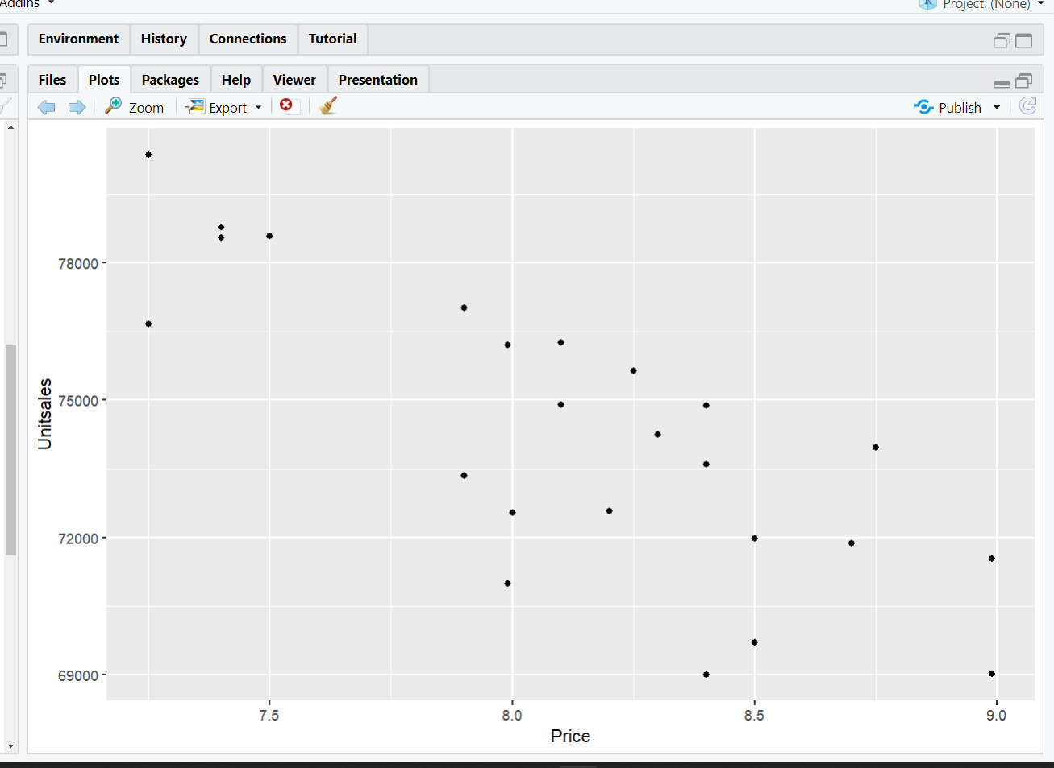

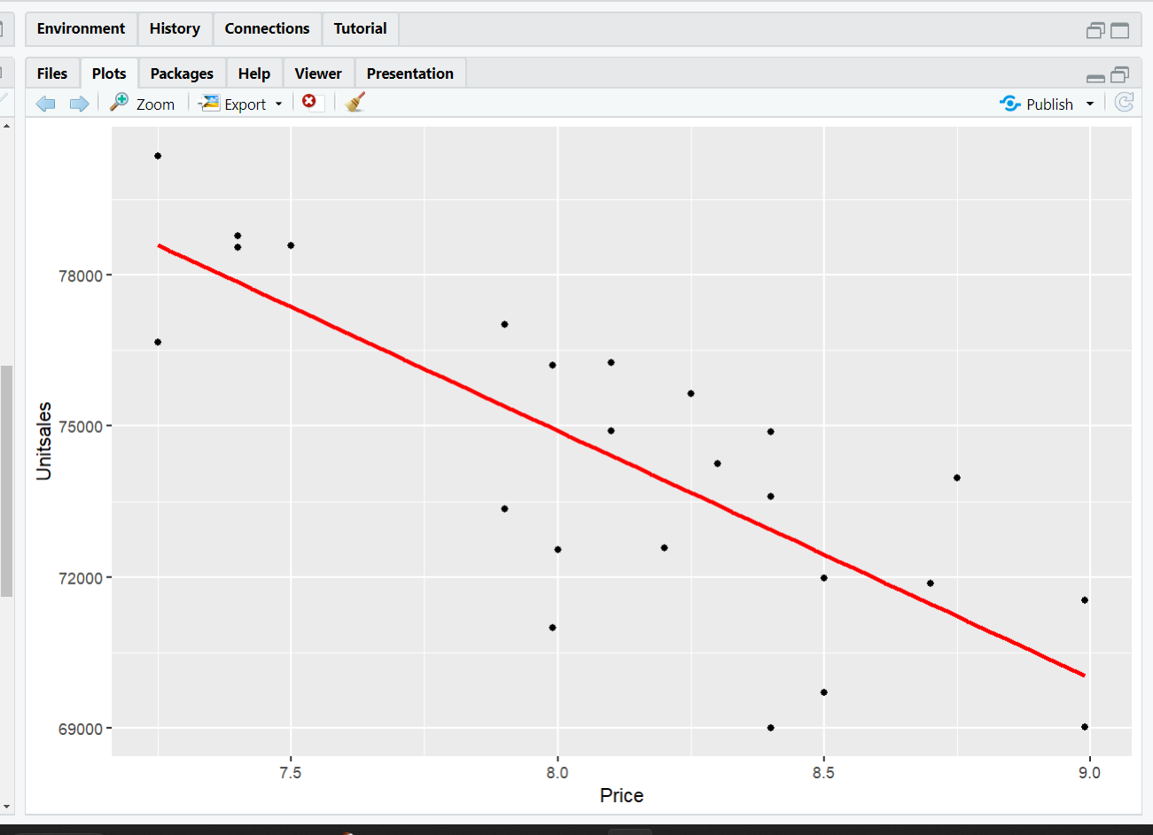

Conclusion: (Write the conclusion in your words. Write the answers to the questions asked in all the above code statements.)

Simple Linear Regression
The value of R-squared for LSR is 0.619
Residual standard error is 1997

- Mulitple Linear Regression
a) The value of R-Squared for SLR is 0.619 while that for MLR is 0.8588
b) Multiple R-Squared variable is more significant having a higher value. Higher value imply that more changes in independent variables corelates to shifts in dependent variable.
c) Yes the Null hypothesis will be rejected as the pvalue is less than 0.05

d) Scenario a will be selected with price 9.1$

